Mark West
Citizens Advisory Council
BLUE BOOK

June 14, 2016

Revised 09-25-2018 (addition of guidelines for using California American Water Franchise Fees)

Revised [date]

TABLE OF CONTENTS

EXHIBIT “A” - MISSION STATEMENT 3
EXHIBIT “B” - RESOLUTION 4
EXHIBIT “C” - REFERRAL AREA BOUNDARY 8
EXHIBIT “D” - RULES AND PROCEDURES 9
EXHIBIT “E” - CONTACT INFORMATION FOR THE COUNCIL 11
EXHIBIT “F” - THE BROWN ACT, AND E-MAIL COMMUNICATIONS 12
EXHIBIT “G” - ADMINISTRATIVE ROLES 13
EXHIBIT “H” - SCOPE OF WORK AND PAYMENT TERMS FOR THE SECRETARY 14
EXHIBIT “I” - NEIGHBORHOOD IMPROVEMENT FUNDING PROGRAM 15
EXHIBIT “J” - SCOPE OF AUTHORITY 21
EXHIBIT “K” - SONOMA COUNTY PLANNING AGENCY 23
EXHIBIT “L” - FREQUENTLY ASKED QUESTIONS 26

EXHIBIT “A” - MISSION STATEMENT

The mission of the Mark West Municipal Advisory Council (“MWMAC”) is to represent the best interests of the entire community while acting as a bridge for communication between the County and local residents and businesses, and the general public on public health, safety, welfare, and quality of life issues affecting the Mark West area.

Specifically, the MWMAC provides a forum for public expression and for making advisory recommendations to the County of Sonoma and its Permit Sonoma, Board of Zoning Adjustments, Planning Commission, Transportation and Public Works (TPW), and Board of Supervisors (BOS) on the following:
- Applications for use permits, rezoning, and general plan amendments (Permit Sonoma)
- Needed transportation and transit improvements or maintenance projects (TPW)
- Allocations of franchise fees in the Mark West Area (TPW)
- Liaise with the Fourth District County Supervisor on community support and outreach for residents in this unincorporated community (BOS)

EXHIBIT “B” - RESOLUTION
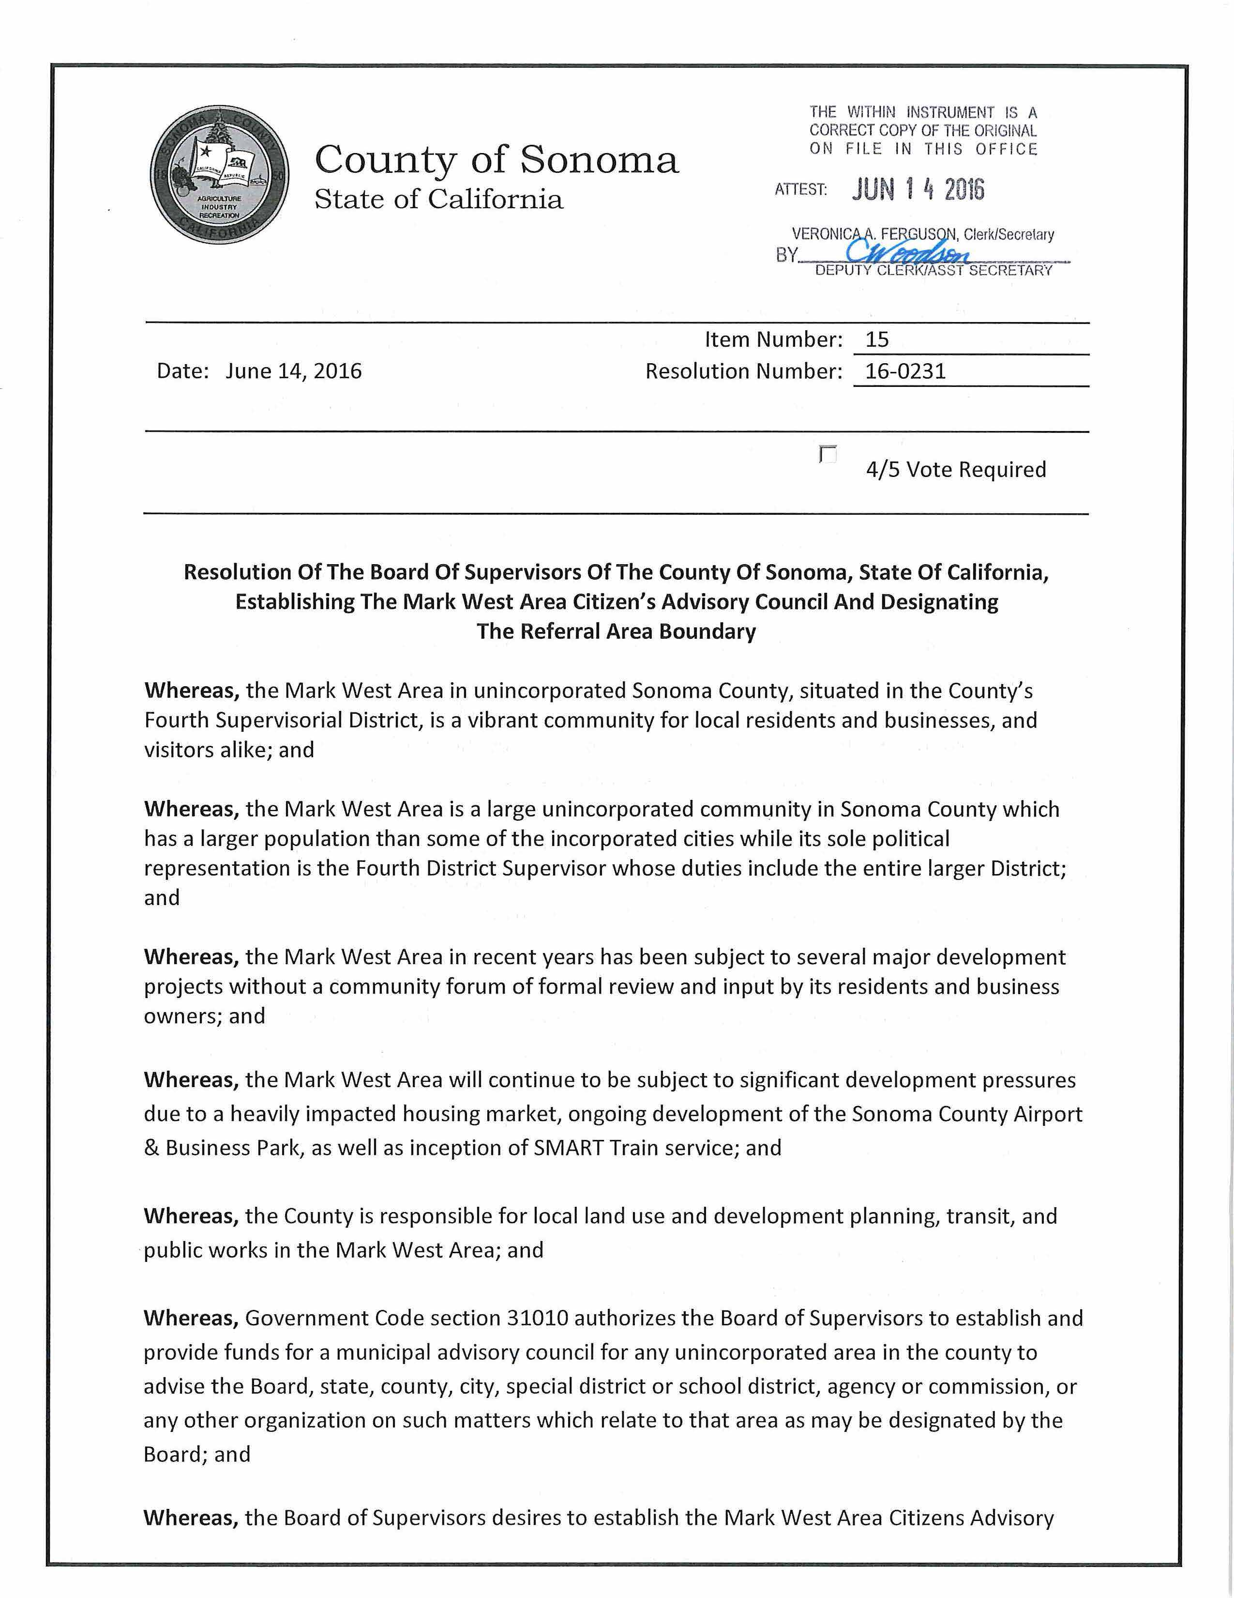

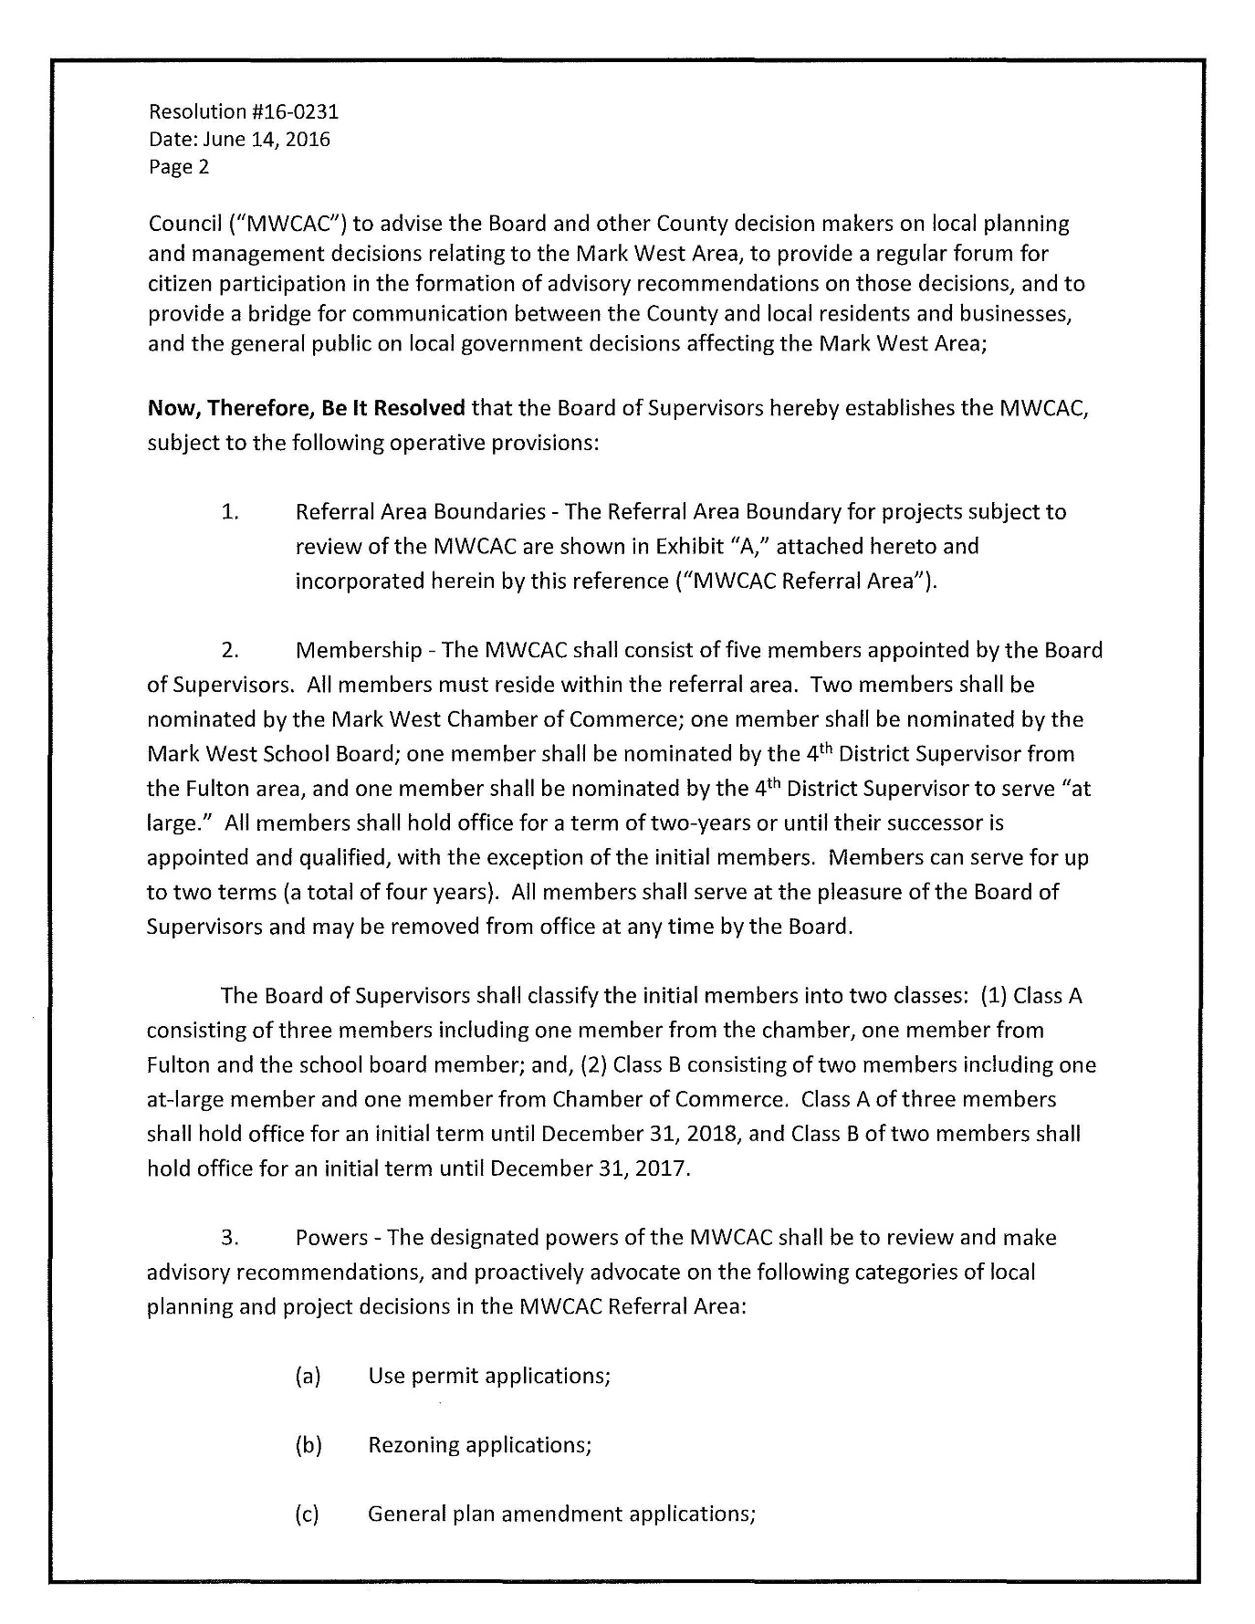

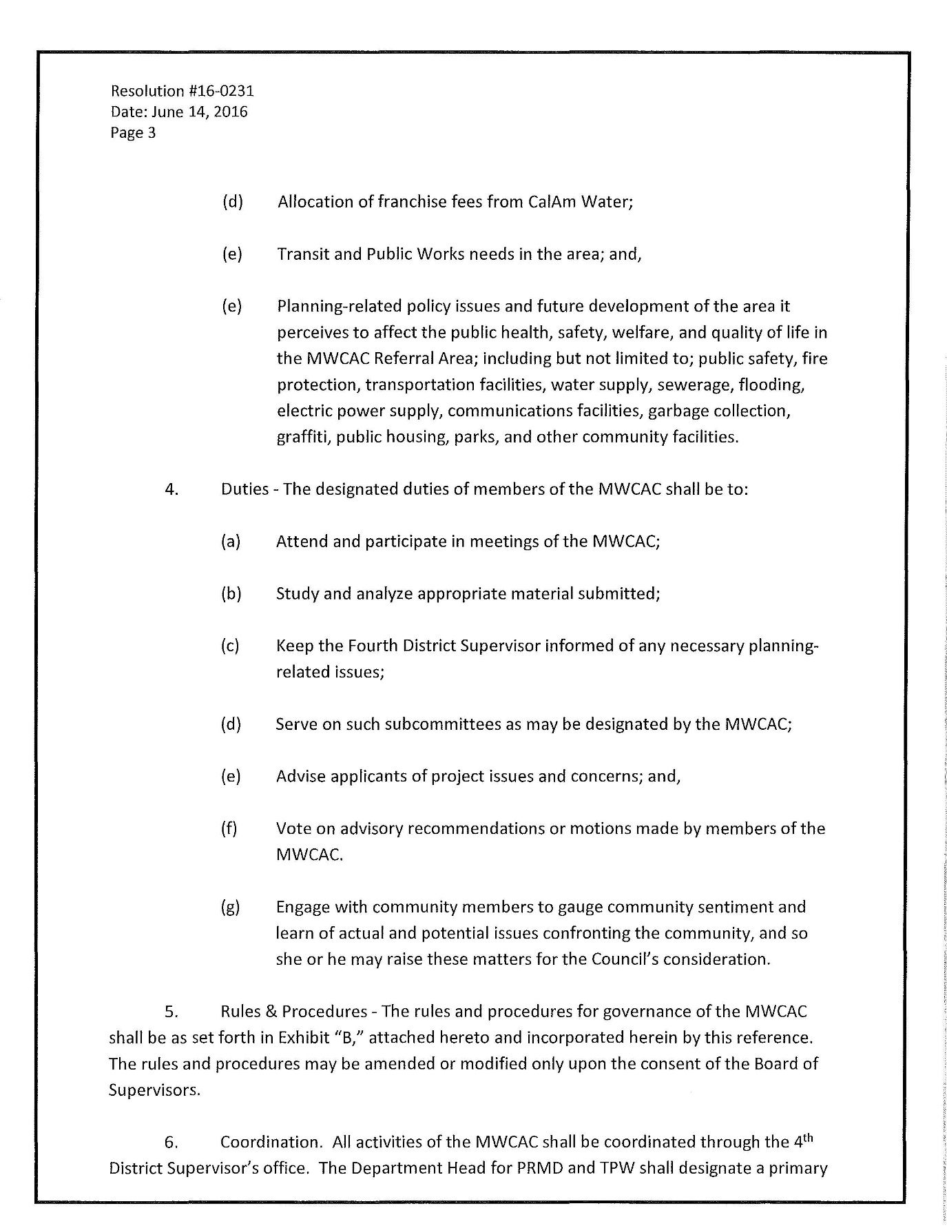

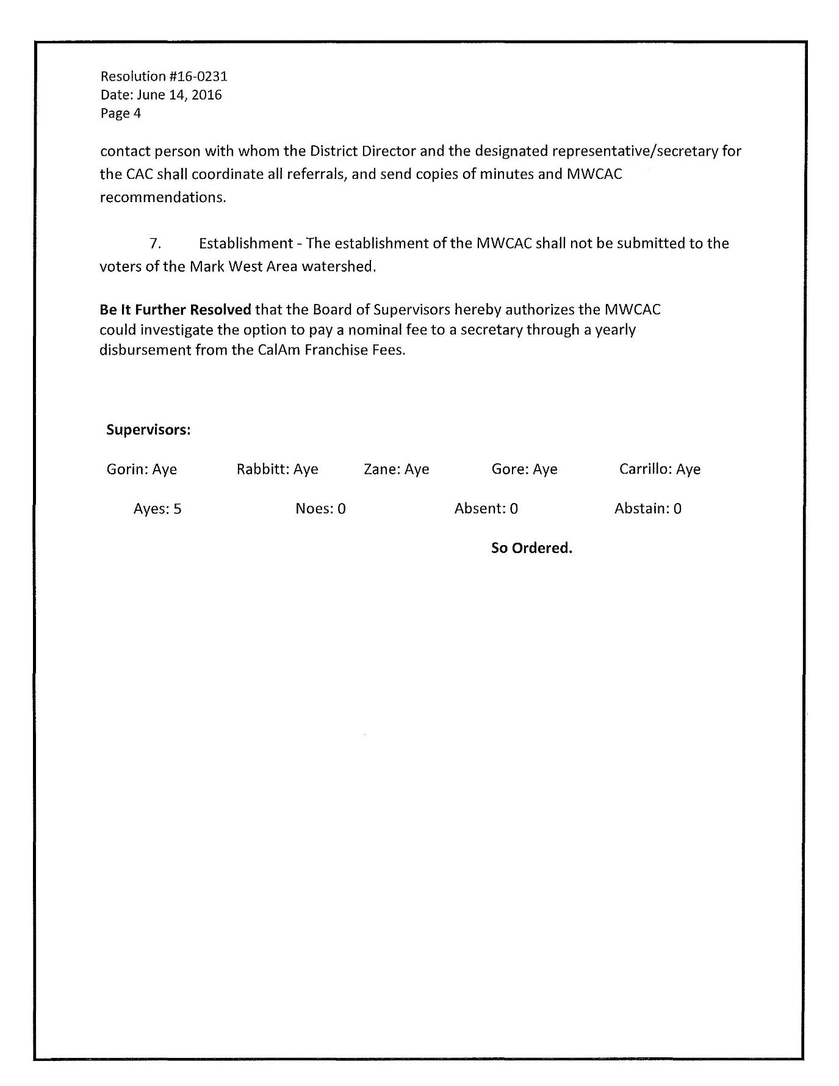

EXHIBIT “C” - REFERRAL AREA BOUNDARY

Need to add a new map.

EXHIBIT “D” - RULES AND PROCEDURES

- MEMBERSHIP

- Appointment. The MWMAC shall consist of five (seven?) members appointed by the Board of Supervisors as nominated in accord with the Membership clause of Resolution 16-0231.
(2) Mark West Chamber of Commerce
(1) Mark West Unified School District Board
(1) Fulton
(3) At Large

- Terms. The MWMAC members shall have term limit of 6 years in 3 two-year terms. There shall be an exception for the member appointed by the Mark West Unified School District Board, who shall not have a term limit, but shall serve at the discretion of the School Board. All other members can be reappointed to the MWMAC if they have a break of service of two-years.

- Quorum and Recommendations. A majority of the members of the MWMAC shall constitute a quorum for the transaction of business. No advisory recommendation of the MWMAC shall be valid or binding unless four-fifths (five-sevenths?) of all the members concur therein.

D. Office. The principal place of business of the MWMAC shall be determined by the MWMAC. At a minimum, there shall be a website where information may be obtained by the public, and a place where the agenda may be publicly posted. This need not be the same place where the MWMAC itself meets.

- E. Compensation. Members of the MWMAC shall serve without compensation.

- F. Vacancies. In event of the death, resignation, or inability to serve of any member of the MWMAC, such condition shall be brought to the attention of the Board of Supervisors for appointment of a replacement. “Inability to serve” shall be determined by a four-fifths (five-sevenths?) (4/5) vote of the MWMAC. If any member of the MWMAC misses two consecutive regular meetings without a valid reason, the Board of Supervisors, through the office of the Fourth District Supervisor, may be notified and requested to appoint a replacement.

- Officers

- There will be two officers for the MWMAC. A Chair and a Vice-Chair.
- Presiding Officer. The chair, or the vice chair in the chair’s absence, shall preside over all meetings of the MWMAC. In the case of absence of both the Chair and the Vice Chair, the Immediate Past Chair shall preside.
- Terms. Terms for the officers will be for two (2) years. Elections will be held each January for any position that needs to be filled.

- MEETINGS

A. Frequency and location of regular meetings. There shall normally be one regular meeting of the MWMAC each month, on a specific, consistent, day of the month, as determined by the chair or a majority of the members of the MWMAC. The time of the meetings shall be scheduled to maximize assistance to the Permit and Resource Management Department, Board of Zoning Adjustments, Planning Commission, Transportation and Public Works, and Board of Supervisors. All meetings of the MWMAC shall be held within the Mark West area. All meetings of the MWMAC shall be in a building easily accessible to the public with facilities to accommodate interested members of the public. Meetings may be held virtually, as determined by the chair.

B. Brown Act. All meetings and all deliberations of the MWMAC shall be open to the public and shall be governed by the Brown Act.

C. Rules of Procedure. All meetings of the MWMAC shall be conducted, insofar as practical, according to Roberts Rules of Order or other parliamentary authority adopted by the MWMAC.

E. Agenda. The chair and the secretary shall be responsible for setting the agenda of each meeting of the MWMAC. The Fourth District Supervisor shall assign Fourth District staff to attend, as needed. The secretary shall post the agenda for each meeting of the MWMAC at the Board of Supervisors office and on the MWMAC website at least 72 hours in advance of the meeting.

F. Voting. Each member of the MWMAC shall be entitled to one vote. A member may abstain from voting in cases of conflict of interest, in which case he or she shall state what the conflict is and recuse themselves from discussion of the item. If sufficient members must recuse him/herself on the same item, a quorum will not be established and the item cannot be formally reviewed by the MWMAC. No proxies shall be permitted. All votes shall be public and properly recorded.

G. Minutes of Meeting. The minutes of each meeting of the MWMAC shall include a copy of the agenda, the official public record of the meeting, and shall indicate any actions taken by the MWMAC. A copy of the minutes shall be sent to the Fourth District Supervisor and to the Permit Sonoma for timely consideration by the appropriate decision-making body of any recommendations contained therein.

H. Special Meetings. Special meetings of the MWMAC may be called at any time by the Chair or a majority of the members of the MWMAC. All special meetings shall be conducted in compliance with the Brown Act.

EXHIBIT “E” - CONTACT INFORMATION FOR THE COUNCIL

See MWMAC webpage

http://sonomacounty.ca.gov/Mark-West-Citizens-Advisory-Council/

EXHIBIT “F” - THE BROWN ACT, AND E-MAIL COMMUNICATIONS

Background:

The Brown Act, enacted in 1953, is intended to ensure that public bodies engage in their deliberations in a public setting. In essence, the Act requires (1) that the public have some notice of issues to be discussed at a meeting, and (2) that issues pending before a body are not discussed in advance by a majority of the members. This requirement prevents members from reaching a decision prior to a publicly accessible meeting.

Both the California Attorney General and the California League of Cities have prepared booklets to assist local government officials in understanding and complying with the Brown Act. The Attorney General’s guide is available at the following website: http://ag,ca.gov/publications/#openmeetings. The Attorney General has created a helpful summary of key Brown Act provisions, which is attached to this explanation. The League of Cities booklet, entitled “Open & Public IV,” can be purchased from the League, and is also available online at www.ci.claremont.ca.us/download.cfm?ID=21498. This booklet includes a number of examples that are useful in determining how the provisions of the Brown Act should be interpreted and applied.

E-Mail Communications:

With the expansion of e-mail and its advantages of convenient, quick communications, many questions have arisen about how the Brown Act and the Public Records Act apply to this communication technology. E-mail should be used with caution: remember, your emails regarding public business are public records. Moreover, emails can result easily in inadvertent violations of the Brown Act.

E-Mail Can Be Used To:

- Distribute meeting minutes, agendas, and drafts of these documents
- Determine member availability for meetings
- To discuss similar administrative issues

E-Mail May Not Be Used To:

- Discuss pending issues before the body with a majority of its members.

Note: A member may discuss pending issues with other members outside of public meetings, as long as fewer than a majority engages in the discussion. The danger with email is that it can be forwarded easily; members are warned that they are responsible for limiting the dissemination of information to fewer than a majority of the body.

EXHIBIT “G” - ADMINISTRATIVE ROLES

CHAIR:

- Preside over all regular meetings. Call for and preside over special meetings when necessary.
- Setting the meeting agenda.
- Appoint members of ad hoc committees
- Acts as a liaison between the MWMAC and the Fourth District Supervisor

VICE-CHAIR:

- Conduct meetings in the absence of the Chair
- Research and report to the MWMAC any problem areas concerning items on the
- upcoming agenda
- Keep a master list of contact persons in governmental and private agencies the
- MWMAC may find useful

EXHIBIT “H” - SCOPE OF WORK AND PAYMENT TERMS FOR THE SECRETARY

The MWMAC shall appoint (either through a voluntary agreement or contract) a Secretary to the MWMAC the first month of each year. The MWMAC could investigate the option to pay a nominal fee to a secretary through a yearly disbursement from the CalAm Franchise Fees.

Administrative Role of Secretary:
(non-member)

- Act as the contact for all potential applicants wanting to present at MWMAC Meetings
- Prepare, distribute and post agendas for meetings at least 72 hours in advance of the meeting
- Keep minutes of all meetings, specifying the call to order, the attendees, the business conducted and the adjourning time
- Arrange sites for all meetings and confirm all necessary public posting requirements are completed in appropriate timelines
- Assist all MWMAC members with compliance with the Brown Act
- Prepare and send communications as directed by the Chair
- Notify members of the MWMAC of special meetings, giving the time, place and reason for meeting
- Keep an up-to-date roster of members of the MWMAC, giving the name, mailing address, phone and fax numbers and email addressees
- Follow up on recommendations made by the MWMAC
- Keep a list of items that the MWMAC has acted upon and report back to the MWMAC on their progress
- Send copies of the minutes to the Fourth District Supervisor’s Office, the Sonoma County Planning Commission and other appropriate bodies as indicated
- Prepare and store the MWMAC member name plates

EXHIBIT “I” - NEIGHBORHOOD IMPROVEMENT FUNDING PROGRAM

Neighborhood Improvement Funding Program
Mark West Municipal Advisory Council

Mark West
Larkfield
Wikiup
Fulton

Made possible by Sonoma County’s
CALIFORNIA AMERICAN WATER Franchise Fees

- FUNDING PROGRAM
A. Program Overview
The MWMAC’s Neighborhood Improvement Funding Program, funded by Cal Am Water franchise fees, supports neighborhood improvement projects in the communities serviced by Cal Am Water—Mark West, Larkfield, Wikiup and parts of Fulton. Please note that the funding may not be eligible to all areas overseen by the MWMAC; only the communities serviced by Cal Am.

Cal American Water Franchise Fees
The California American (Cal Am) Water Franchise Fees were established in 2009 by the Sonoma County Board of Supervisor’s (BOS) resolutions below.
- 11/17/09 BOS Resolution No. 09-1089 of intent to establish franchise fees with Cal Am Water
- 12/8/09 BOS Ordinance No. 5861 granting a franchise to Cal Am Water

The franchise fee is paid to the County for the use of “County streets to supply water to consumers in connection with the regulated water system owned and operated by Cal Am in the Mark West-Larkfield-Wikiup area of unincorporated Sonoma County” which includes parts of Fulton.

The Resolution No. 09-1089 states that,
WHEREAS, the Board intends to pass through a portion of the franchise fees from Cal-Am to a new Community Services District in the Mark West Larkfield-Wikiup area, subject to approval of the CSD by the Local Agency Formation Commission and voters in the area;

“...two percent (2%) of the gross annual receipts of Cal Am arising from the use, operation, or possession of the Franchise” would go to the County for a “term of 20-years, and may be extended by mutual agreement.”

The funds are administered by the Sonoma County Department of Transportation & Public Works (TPW) within their regular budgeting functions. The fund balance (as of 4/2018) is ~$200,000 with ~$33,000 coming in each year after the October 2017 fire damage.

B. Eligibility and Criteria
Residents of Mark West, Larkfield, Wikiup and parts of Fulton who are serviced by Cal Am Water are eligible to apply. Projects must identify the benefit(s) to the community, and have a specific timeline with defined steps and costs. Costs must be broken down by line item. Justification will be provided for anticipated costs. A minimum of three written bids may be requested for each project if an outside vendor is to be used. For instance, if materials must be purchased, the applicant should provide the cost of purchasing those materials at current prices. Funds cannot be used for any “ongoing” costs after the project’s completion (examples: maintenance, watering, electricity, etc.) If there are “ongoing” costs to the project, detailed explanations as to how those costs will be met must be included.

C. Project Examples
The intent of the funds is for “public good” projects with a onetime cost. Public good projects that increase neighborhood pride and identity such as community gardens, bicycle racks, picnic tables, benches, signage, curb appeal enhancements, etc. The MWMAC approves the proposals for funding and encourages residents to look around their neighborhoods for projects that all residents can enjoy and be proud of. (Previously funded project: Fulton “Welcome” signs.)

D. Community Involvement
A group of three or more active and involved residents in Mark West, Larkfield, Wikiup and Cal Am Water customers in Fulton can apply for the Neighborhood Improvement funds. In addition, groups such as an homeowners association or a non-profit can also apply.

E. Project Design
Projects must be detailed and include site specific drawings, photographs, maps and any other supporting documentation that would assist the MWMAC’s understanding of the project. The application must demonstrate that the project will meet all local, state and federal codes, if applicable.

- FUNDING APPLICATION PROCESS
A. How to Apply
Complete the application form and email the application to theMWMAC Secretary, Aggie Maggio aggiemaggio@icloud.comOr in person at a MWMAC meeting (if applicable).

B. Application Submission Dates
Applications are accepted by the MWMAC at any time. There is not a “first come first served” policy.

C. Application Review and Approval
The MWMAC’s NIFP Subcommitteewill review and select projects to be considered by the full MWMAC. If funding is available, the MWMAC will request payment by TPW. Occasionally, a project may need to be considered by the Board of Supervisors. This review process will include discussions with the County to determine the proper procurement methods for the project. Once the projects are reviewed they will be considered by the Board. If the Board approves a project the applicant will be receive a notice to proceed in writing from the secretary of the MWMAC.

D. Funding or Reimbursement
Funds can be distributed before or after a project is completed.
- If funding is requested prior to completion:
  - After the MWMAC and/or Board of Supervisors approves the project, the applicant may be awarded funding up front. The amount should be consistent with the costs detailed in the application. Once the project is complete, the applicant will submit all receipts to be reviewed by the MWMAC. The applicant will also return any unused funds. If the use of funds is inconsistent with the application the MWMAC may request reimbursement from the applicant.
- If funding is reimbursed:
  - After receiving and confirming all project expenditures the MWMAC will submit the project for payment (payable to the designated neighborhood contact person/leader or vendor).

MARK WEST CITIZEN’S ADVISORY COUNCIL

Neighborhood Improvement Funding Program
Application Form
FY 2018-2019

This application is used for Cal American Water Franchise Fee Funds for the areas of Mark West, Larkfield, Wikiup and parts of Fulton.

Applications may be submitted via:
Email: MWMAC Secretary, Aggie Maggio aggiemaggio@icloud.com
In Person: MWMAC meetings— Second Monday of the month.
Time & location: sonomacounty.ca.gov/Mark-West-Citizens-Advisory-Council

Neighborhood groups will be required to present their projects to the MWMAC at a monthly meeting.

Please print or type via fillable pdf.

- Neighborhood Group Name(s) & Addresses:

- Primary Contact Person (Leader):

- Leader Email Address:

- Leader Mailing Address:

- Leader Phone Number:

- Neighborhood Project Description (include the community NEED it will be addressing):

- Does the Project require permits, and does it meet all local, state and federal codes? Please list the sources you consulted to answer this question.

- How will the project engage or utilize volunteers, neighbors or residents?

- Description of Project Location (Attach a map that details the footprint of the project):

- Project Scope of Work (detailed explanation of the project steps):

- Project Timeline:

- Amount of Funds Required:
[ ] Before project begins

[ ] Reimbursed after completion

- Summary of Project Costs (attach a spreadsheet with a line item for each costs, which includes permit costs, the unit costs of materials, the amount of each material, labor costs, and a justification for each figure). If a vendor is needed, please provide copies of at least 3 bids:

- Are there ongoing costs to the project such as maintenance or repairs? If so, please explain how these costs will be financed.

- What is the lifetime of the project? Will it have to be removed or replaced after its lifetime? Who will maintain responsibility?

EXHIBIT “J” - SCOPE OF AUTHORITY

The Mark West Area Citizens Advisory Council (MWMAC) is charged with examining, discussing, and making recommendations regarding Use Permits, Rezoning and General Plan amendment applications within the Mark West Area. Additionally, they will make annual recommendations on allocations of the CalAm Franchise Fees, and advise the 4th District Supervisor on Transit and Public Works priorities.

The MWMAC is additionally authorized to pro-actively advocate for policies and projects it perceives as necessary to resolve potential and actual issues confronting the community or to improve the quality of life of the community. In so doing it is further granted the authority to solicit, apply for and accept funding from sources outside of the County budget whether by grants or private donation. Such funds shall be accounted for separately from the Franchise Fee funds and shall be tracked and reported to assure they are allocated to the designated purpose.

Site Review. All proposed use permits, rezoning applications, and General Plan amendments occurring in the Mark West Area watershed may be visited on-site by any member of the MWMAC or by an ad-hoc committee, appointed by the MWMAC chair, consisting of at least two MWMAC Members. MWMAC Members will coordinate site visits directly with the applicant or owner.

Ad Hoc Committee Report. Any appointed ad-hoc committee will report to the full MWMAC at its next regularly scheduled meeting. The applicant or their representative will be expected to attend to make a presentation on their proposal and answer questions from MWMAC Members and interested community attendees.

MWMAC Review. The MWMAC will recommend to the County’s Permit Sonoma its 4/5 5/7? consensus view after considering the ad-hoc committee’s report and any supplemental information supplied by the project applicant. Should the applicant or their representative not attend the MWMAC’s review, the MWMAC may make its recommendation based upon other information supplied by the ad-hoc committee and the County’s Permit Sonoma. As with any other project, any MWMAC Member having a personal or professional relationship with the applicant that would bias the member’s judgment should refrain from participating in the review.

Advisory Recommendation. Minutes of the meeting detailing the MWMAC’s recommendations will be forwarded by the MWMAC’s Secretary to the County’s Permit Sonoma with a copy to the project applicant.

Mark West Springs area use of Cal Am franchise fees. Annually, the County collects approximately $40,000 in franchise fees from CalAm for services provided in the Mark West Springs area. The MWMAC shall consider the available funds and may make recommendations for the expenditure of these funds, within the following guidelines:

- In December of each year, the Department of Transportation and Public Works shall provide the MWMAC with an estimate of available funds effective the beginning of the next fiscal year.
- The annual recommendation for the use of funds is due from the MWMAC by March 1, and should be submitted to the Department of Transportation and Public Works, for inclusion in the annual budget.
- Recommendations shall be within the available fund balance, and shall be for one-time expenditures that benefit the Mark West Springs Community. These funds are not available for on-going maintenance, and any recommendations that create an on-going maintenance need must include a commitment of funding from another source to support the on-going maintenance.
- Recommendations will be included in the annual recommended budget submitted by Transportation and Public Works.
- Funds may be accumulated over time to accomplish larger projects.

EXHIBIT “K” - SONOMA COUNTY PLANNING AGENCY

The Planning Agency (Planning Commission and the Board of Zoning Adjustments) serves primarily as the recommending body to the Planning Commission, Board of Zoning Adjustments and Sonoma County Board of Supervisors.

The Planning Agency consists of ten commissioners who are appointed by and serve at the pleasure of the Board of Supervisors. The commissioners rotate sequentially by district every ten months. The chairmanship of each body rotates yearly by district.

The Planning Commission holds public meetings and makes recommendations to the Board of Supervisors concerning updates and amendments to the County’s General Plan and Zoning regulations. The Planning Commission also holds hearings and makes decisions on major subdivisions and mining proposals. There are five members who sit on the Planning Commission with one alternate for each district.

The Board of Zoning Adjustments conducts public hearings and makes decisions on applications for Use Permits, Zoning Variances and Coastal development Permits. There are five members who sit on the Board of Zoning Adjustments with one alternate for each district.

Permit and Resource Management Department
POLICY AND PROCEDURE Number 8-1-11

PURPOSE

The purpose of this policy is to define the circumstances in which the County of Sonoma refers projects and applications to the Mark West Municipal Advisory Council (MWMAC) for comment.

GENERAL

All applications for General Plan Amendments, Rezonings, and Use Permits within the Mark West Area as shown on the attached Exhibit A shall be referred to the MWMAC for review and comment.

AUTHORITY

The Sonoma County Board of Supervisors created the MWMAC by Resolution No. 16-0231 to serve as an advisory body on applications for use permits, rezoning and General Plan amendments within the Mark West Area.

PROCEDURE
- Following a determination that a proposal is subject to MWMAC review, the County of Sonoma Planning staff shall deliver or have delivered a copy of the project application, and any available supporting materials to the Chairperson of the MWMAC.

- The Chair will determine, with the MWMAC’s Secretary, whether to place the project on the next available agenda of the MWMAC for comment.

- If the item is brought to the MWMAC for comment, it shall be the responsibility of the MWMAC to prepare and deliver written minutes of the action to the County of Sonoma planning staff in a timely manner so that they may be forwarded to the hearing body at the time of project review.

- The hearing body shall consider the comments of the MWMAC in the course of its review of the project, but the comments shall not be considered binding and the hearing body shall act on the project application as it deems fit.

- Project applicants must attend MWMAC meetings when their project is being heard by the MWMAC.

- Projects referred to the MWMAC for comment shall be reviewed by the MWMAC within 45 days after the referral. The failure of the MWMAC to make an advisory recommendation within 45 days after the referral shall be deemed to mean that the MWMAC has no recommendation on the project.

- This policy does not preclude the County of Sonoma or planning staff from referring issues to the MWMAC for advice and comment that may not be subject to environmental review as defined by this policy.

RESPONSIBILITIES AND REVIEW

- The County of Sonoma is responsible for reviewing this policy no less than every ten years to determine whether it is still representative of the Mark West Area and still an effective review board for the County. Changes may be made by a majority vote of the Board of Supervisors.

- The Sonoma County Board of Supervisors will review this policy from time to time, as it deems necessary.

EXHIBIT “L” - FREQUENTLY ASKED QUESTIONS
FOR PROJECT APPLICANTS APPEARING BEFORE THE MWMAC

Congratulations on appearance before the Mark West Area Citizens Advisory Council (“MWMAC”) to discuss your proposed use permit, rezoning application, or request for a General Plan amendment. Your participation can give you important insight into the reaction your project will generate from concerned neighbors and citizens in the Mark West Area.

This guide is intended to help you prepare for your hearing by describing the process, and listing the types of questions you might expect to hear from the MWMAC. If you have further questions or concerns, please contact the MWMAC Chair.

What is the MWMAC?

The MWMAC is an advisory body formed by the Sonoma County Board of Supervisors. The group is chartered with the following mission statement:

The mission of the MWMAC is to act as a bridge for communication between the County and local residents and businesses, and the general public on local planning decisions affecting the Mark West Area.

The MWMAC provides a forum for public expression and for making advisory recommendations to the County of Sonoma and its Permit Sonoma Department, Board of Zoning Adjustments, Planning Commission, and Board of Supervisors on applications for use permits, rezonings, and general plan amendments in the Mark West Area.

With respect to Planning, the three main functions of the MWMAC are to discuss, review and make recommendations regarding development proposals located in the Mark West Area specifically related to:

- Use permits
- Rezoning Applications
- General Plan Amendments

Who Sits on the MWMAC?

The Sonoma County Board of Supervisors appoints five (seven?) members to the MWMAC. All members must reside within the defined MWMAC area. Two members shall be nominated by the Mark West Chamber of Commerce; one member shall be nominated by the Mark West Unified School District Board; one member shall be nominated by the 4th District Supervisor from the Fulton area, and one (three?) member(s) shall be nominated by the 4th District Supervisor to serve “at large.” All members shall hold office for a term of two (six?)-years. Members can serve for up to two (three?) terms (a total of four (six) years). All members shall serve at the pleasure of the Board of Supervisors and may be removed from office at any time by the Board, with or without cause.

In addition, the Fourth District County Planning Commissioner may attend meetings as an ex-officio member. The Planning Commissioner is not eligible to vote at MWMAC meetings.

The MWMAC has two officers (Chair and Vice Chair) and one private position (Secretary). The Chair is responsible for conducting meetings and setting the MWMAC agenda. The Vice Chair supports the Chair in business matters. The Secretary, which is an independent contract position and is hired and compensated by the MWMAC and is responsible for public posting of the meetings, attends meetings and prepares the minutes of each meeting, as well as maintaining files. Officers serve for two year terms, with elections in January. Officers cannot serve more than two consecutive terms.

Why was my Project Selected for Review by the MWMAC?

The Chair of the MWMAC, with the assistance of the MWMAC Secretary, selects projects and application proposals for review based on his or her judgment of the potential impacts that the project may have on the Mark West Area.

My Plans are only Conceptual at This Point; Should I present them now?

The advantage to appearing before the MWMAC when your project is only in the conceptual stage is that you can get a sense of the community’s response to your plans before spending a lot of time and money on a full-fledged design.

The disadvantage is that the MWMAC is more likely to be unwilling to recommend approval of your plans/proposal without seeing final details, so they may ask you to reappear when you have completed your planning.

The risk of appearing late in your project planning process is that the MWMAC may recommend significant changes, or even recommend that your project be denied approval.

For projects that may generate community opposition or concerns, you might consider holding local community/neighborhood meetings before filing for a permit application.

Most projects are handled in one hearing; however, it may be to your advantage to return to the MWMAC for consideration of your revised plan.

What Are the Key Areas of Concern that the MWMAC Members are Likely to Raise?

Concerns will inherently vary, based on the type of project or proposal being reviewed. Often these topics come up during Commission meetings:

- Traffic generation
- Evacuation protocols
- Parking
- Event Activity
- Scope of use permits
- Concentration
- Water use
- Sanitation and other matters of health and safety
- Well, septic, drainage and ground water questions
- Noise
- Visual impacts
- Appropriateness of project given zoning and other land use designations
- Preservation of trees and native habitats
- Other environmental impacts

How are MWMAC Meetings Organized?

A regular meeting begins with a roll call and the approval of the minutes, followed by an opportunity for members of the public to address the MWMAC on matters not otherwise on the agenda.

Typically a series of proposed projects and applications are then reviewed. Finally, the MWMAC considers administrative issues, and reports from ad hoc committees.

What Procedures Are Followed for the Project Review?

Applicants or their representatives make a brief presentation before the MWMAC, followed by a period for MWMAC members to ask questions. The public is then given an opportunity to ask questions and/or comment on the project.

The Chair will then close the public comment portion of the review, and MWMAC members will then discuss the project and make a recommendation or pass a resolution, if warranted. Please note that once the public comment portion of the review is closed, any additional comments or answers to materials from the MWMAC members should be addressed through the Chair.

How Should I Plan my Presentation?

The best presentations begin with a complete application package. MWMAC members often receive abbreviated project applications from the County, and if there is additional information that you would like them to have, please work with the Council Secretary to get the materials to the MWMAC members in advance of the meeting.

A concise presentation is often better than a comprehensive one. Assume that the MWMAC members have reviewed the package of information that describes your project, so your description of the application can be brief. It is helpful to describe exactly what approval you are seeking (i.e. a zoning change or a use permit) and what level of project planning you have completed (is this is conceptual review, or are there well-developed plans?).

Focus on the impacts that your project will have and how you intend to mitigate them. What concerns are neighbors of the project likely to have? Have you notified them of your plans, or held a meeting with them yet?

MWMAC members will focus on their concerns during the question and answer period, so it is not necessary to try and anticipate and answer every concern in your presentation. If you would like guidance regarding preparation for your appearance, don’t hesitate to contact the Chair in advance of the meeting.

How Should I Handle Questions and Comments from the Audience?

During the open comment period, members of the audience will have the opportunity to ask questions and state their opinions about your proposal. We recommend that you answer questions forthrightly and concisely. You should not feel obligated to respond to statements of opinion.

The Chair will help moderate this portion of the hearing. If the project is likely to engender a level of controversy or extensive feedback from the community, the Chair will likely establish guidelines for the public comment period, potentially including time limits for each speaker.

What Happens to the Recommendations Made by the MWMAC?

The MWMAC Secretary will capture all aspects of the project review in the meeting minutes. Minutes are distributed to the Sonoma County Fourth District Supervisor and to the County’s Planning department.

One of the MWMAC members appointed by the County is also charged with meeting directly with planning staff to review specific projects. The Sonoma County Planning Commissioner from the Fourth District is usually in attendance to hear discussion of projects, but will not take part in the question period.

I Don’t Like the Resolution Passed by the Council … Now What?

Please remember that MWMAC reviews are advisory in nature, and that you can certainly continue seeking approval for your project at the County. However, the MWMAC strives to reflect the concerns and sense of opinion of the Mark West Area, and you could consider putting this information to good use.

Can you modify your proposal to address the significant concerns raised at the hearing? If you choose to do so, you might also consider asking to appear before the MWMAC again to review your modified plans.

