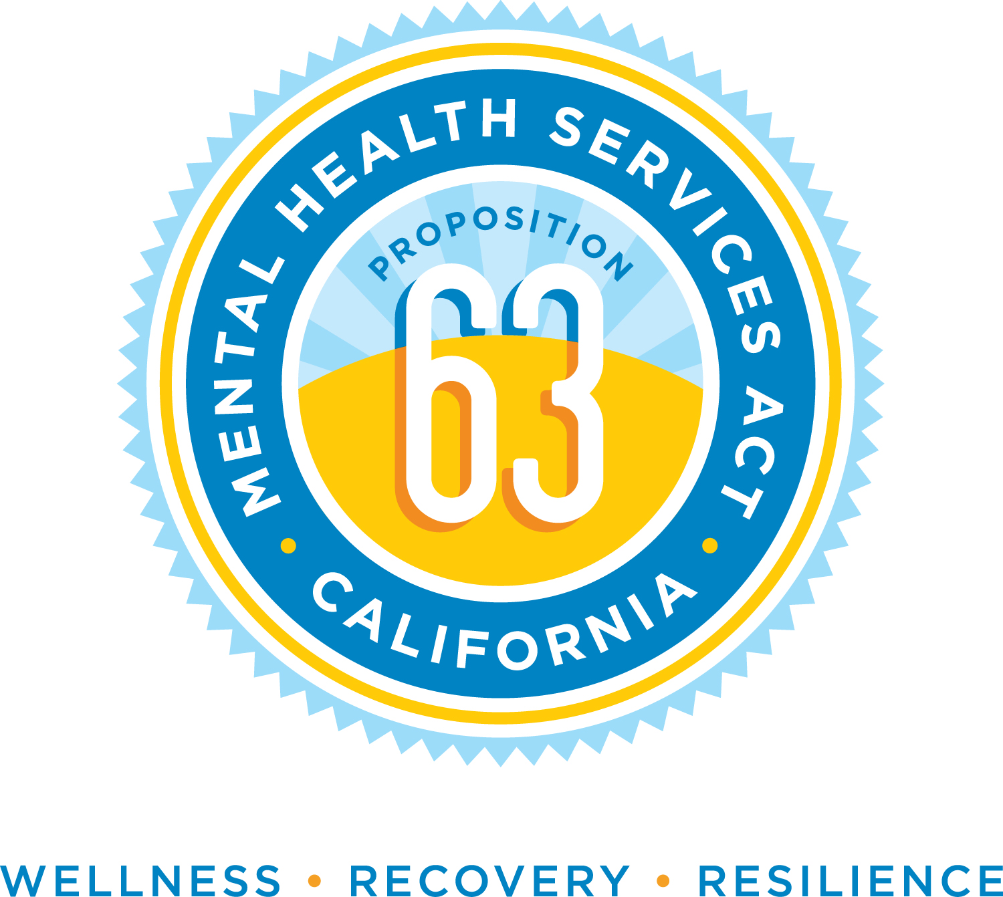
Mental Health Services Act
Innovation 2020
APPLICATION
DEADLINE: OCTOBER 18, 2019

Overview: The Mental Health Services Act (MHSA) provides limited funding (5% of total MHSA funds) dedicated to the Innovation Component of the County’s MHSA Plan. Funding will be used to increase access to underserved groups; increase the quality of services, including better outcomes; promote interagency collaboration; and increase access to services.
Innovation Projects are defined as: Novel, creative, and/or ingenious mental health practices or approaches that are expected to contribute to learning, and are developed within communities through a process that is inclusive and representative. The Innovation Component allows Counties the opportunity to “try out” new approaches that can inform current and future mental health practices/approaches. Innovation ideas will introduce a new practice, adapt an existing practice for a new setting, or introduce a new practice that has been successful in a non-mental health setting. For more information visit the Sonoma County Department of Health Services Behavioral Health Division website at: http://sonomacounty.ca.gov/Health/Behavioral-Health/Mental-Health-Services-Act/
Guidelines: Any organization or collaborative may apply for Innovation funds. Please complete the Innovation 2020 Application and send it to Melissa Ladrech, MHSA Coordinator by email or Melissa.Ladrech@sonoma-county.org no later than October 18, 2019 at 4:00 pm or by mail to Melissa Ladrech, Department of Health Services: Behavioral Health Division,
2227 Capricorn Way, Suite 207, Santa Rosa, CA 95407 post marked no later than October 18, 2019.
NOTE: Completed applications have a 15 page limit with 1 inch margins and 12 point font.

- Description of Proposed Innovation Project

“Innovative Project”: This is a project that the county designs and implements for a defined time period, and evaluates to develop new best practices in mental health. An Innovative Project meets one of the following criteria: | Select  One
- Introduces a new approach or an approach that is new to the overall mental health system, including, but not limited to, prevention and early intervention. | ☐
- Makes a change to an existing practice in the field of mental health, including but not limited to, application to a different population | ☐
- Introduces a new application to the mental health system of a promising practice or approach that has been successful in a non-mental health context | ☐

- A mental health practice that has already demonstrated its effectiveness and could be funded with other MHSA funds is not eligible for funding as an Innovation Project.

- Based on the selected criteria for Innovation in above table, how does the proposed project meet criteria for Innovation Funding?
  - Include citations of research conducted that verify your Innovation Project meets the definition of Innovation. Specifically, how is the proposed project expected to contribute to the development and evaluation of a new or changed practice within the mental health field? (Please include any supporting research that citations are from as an appendix to the application.)

  - Differentiate the elements that are new or changed from existing practices in mental health already known to be effective.

- Describe the unmet mental health needs that your Innovation Project will address. Support your defined unmet need with findings and citations from local data, research and/or reports.

- Describe the population to be served with demographic information such as age, gender, race, ethnicity, and language if applicable. Describe the expected number of clients to be served annually. (May not be applicable if the Innovation Project is a systems or infrastructure improvement)

- How is this population currently being served, unserved or inappropriately served? Was the population to be served consulted in identifying their needs and desired supports and services? (May not be applicable if the Innovation Project is a systems or infrastructure improvement)

- Briefly describe a timeline that identifies key milestones for life of project. The time frame of the proposed project should not exceed three years. Include all aspects of the project: development, community engagement, implementation, evaluation, and dissemination of the results and lessons learned. (See suggested sample timeline, Attachment A).

- Identify Primary Purpose of Proposed Innovation Project

Primary Purpose: The project shall have at least one of the following purposes for developing and evaluating a new or changed mental health practice: | Select  All That Apply
- Increase access to unserved or underserved groups | ☐
- Increase quality of mental health services, including better outcomes | ☐
- Promote interagency collaboration related to Mental Health Services or supports | ☐
- Increase access to mental health services | ☐

- Focus on Mental Health: An Innovation Project may impact virtually any aspect of mental health practice or assess a new or changed application of a promising approach to solve a persistent, seemingly intractable mental health challenge in the community.

- Innovation projects are to address a priority issue that the county and community stakeholders have identified. This priority issue can be related to population or place-based mental illness or an aspect of the mental health service system that needs improvement. What challenge does the proposed Innovation Project seek to address? How is this challenge consistent with the Primary Purpose selected above?

- How have stakeholders been involved in the identification of the priority issue to be addressed? How have stakeholders been involved in the proposed solution to the priority issue?

- How will the Innovation project address the needs identified? How will the proposed approach be culturally effective?

- Evaluation of Proposed Innovation Project

Evaluation: The proposed project must have a design and method for evaluating the effectiveness and feasibility of the Innovation Project. If necessary, the County can provide technical assistance in refining the evaluation plan.
- Innovation Projects are to have a minimum of two learning goals. What are the learning goals for the Innovation Project? How can these learning goals benefit the mental health service delivery system in Sonoma County?

- How will the proposed Innovation Project be evaluated for the selected primary purpose? Describe the intended outcomes, specific indicators, and evaluation methods. See sample evaluation plan format, Attachment B.

- How will the evaluation assess the effectiveness of the key elements of the project? Please include identified baseline data that will be used to compare and demonstrate changes in the MH system or service outcomes as a result of the proposed Innovation project.

- How does the project intend to ensure the evaluation of the Innovation Project is culturally appropriate and include meaningful involvement by diverse community stakeholders?

- How will the evaluation of the Innovation project be disseminated to the community for future application?

- Describe how it will be determined whether to continue the Innovation Project or portions of the project beyond Innovation funding. If direct service, how will individuals and families receiving services through the proposed project be protected and how will continuity of care be provided after the end of Innovation funding?

- Projected Cost of Innovation Project

- Please provide the projected cost of the proposed Innovation Project. Include in your estimated costs: Personnel, operations, administrative overhead. (See sample budget template, Attachment C)

- Is your Innovation project supported solely with Innovation funding or will Innovation funding enhance, improve an existing program/service? If funds will be combined/matched with another source of funding, please list the source(s) of those funds and describe how secure those funds are for your agency.

- Agency Infrastructure

  - Describe your organization’s ability to meet contract requirements, including reporting, collecting data, conducting an evaluation and tracking funding. If your organization is partnering with another agency for this support, please describe that organization’s capacity.

Attachment A: Sample Project Timeline

- Tasks | - Mar 2020 | Apr 2020 | May 2020 | Jun 2020 | Jul 2020 | Aug 2020 | Sep 2020 | Oct 2020 | Nov 2020 | Dec 2020 | - Jan 2021 | Feb 2021 | Mar 2021 | Apr 2021 | May 2021 | Jun 2021 | Jul 2021 | Aug 2021 | Sep 2021 | Oct 2021
- Award of Innovation Project(s)
- Begin Innovation Project
Project Planning and Development

Community Engagement

Project Implementation

Evaluation
Dissemination of Results

Attachment B1: Sample Evaluation Plan

Community Need: Residents in rural areas lack MH support and services

Learning Goal(s):
  - To determine if a system of care for residents of rural areas of the county can be effective in supporting mental health prevention and early intervention.
  - Is a mental health telecare model combined with in-person mobile response a cost-effective service and support for residents living in remote areas?

Primary Purpose | Desired Outcome(s) | Indicators | How Measured
Increase access to underserved groups | Establish a responsive system of care for residents in rural areas | Program model documented and vetted by stakeholders  Staff hired and trained | Documentation of program model  Personnel documentation
Increase access to mental health services | Engage rural residents in utilizing a telecare service with connectivity to mobile clinicians | Launch date  Number of calls  Number of referrals to clinicians based on PHQ-9  Number of cases opened | Tracking number and type of calls to MH line  PHQ-9 documentation  Clinician case documentation
Increase quality of MH services, including better outcomes | Rural residents have improved MH status, appropriately utilize support services | Decrease in Utilization of crisis services  Less criminal justice interaction  Increase in client social and emotional support | Comparison of prior data to current data at CSU, emergency rooms and w/ Sheriff’s Department  Self-reported by consumers via surveys

Attachment B2: Evaluation Plan Template

Community Need:

Learning Goals:

1.

2.

Primary Purpose | Desired Outcome(s) | Indicators | How Measured

Attachment C: Sample Budget Template

Expenditures
Personnel Costs (Salaries, wages, benefits) | FY19/20 | FY20/21 | FY21/22 | FY22/23 | TOTAL
- Salaries
- Direct Costs
- Indirect Costs
- Total Personnel Costs
Operating Costs | FY19/20 | FY20/21 | FY21/22 | FY22/23 | TOTAL
- Direct Costs
- Indirect Costs
- Total Operating Costs
Non Recurring Costs (equipment, technology) | FY19/20 | FY20/21 | FY21/22 | FY22/23 | TOTAL
8.
9.
10. Total Non-recurring costs
Consultant Costs/Contracts (clinical, training, facilitator, evaluator) | FY19/20 | FY20/21 | FY21/22 | FY22/23 | TOTAL
11. Direct Costs
12. Indirect Costs
13. Total Consultant Costs
Other Expenditures (please explain in budget narrative) | FY19/20 | FY20/21 | FY21/22 | FY22/23 | TOTAL
14.
15.
16. Total Other Expenditures
Budget Totals
Personnel (line 4)
Direct Costs (lines 2+5+11)
Indirect Costs (lines 3+5+12)
Non-recurring Costs (line 10)
Other Expenditures (line 16)
Total Innovation Budget

